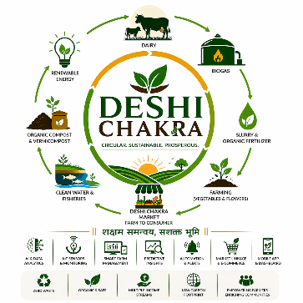
LOGO
Home Page
Vision :
Building Prosperous Rural Ecosystems for a Self-Reliant India
To create a scalable, technology-enabled ecosystem that transforms agriculture, livestock, renewable energy, and rural enterprises into interconnected engines of prosperity, empowering communities and contributing to a stronger and more sustainable India.
Mission
Our Mission is to Create Value Through Circular Growth
We aim to:
- Empower farmers, producers and rural entrepreneurs through integrated ecosystems.
- Convert waste into wealth using circular economy principles.
- Promote sustainable agriculture, renewable energy and resource efficiency.
- Leverage AI, IoT and digital technologies to improve productivity and profitability.
- Enable direct market access and create multiple income streams.
- Generate employment and strengthen rural communities.
- Build a scalable model that can be replicated across India.

Core Philosophy
Sustainable Today. Profitable Tomorrow.
At Deshi Chakra, nothing is wasted and everything creates value.

Guiding Principles
♻ Circular Economy
Every resource is utilized and transformed into value.
🌱 Sustainability
Promoting environmentally responsible growth.
🤖 Technology with Purpose
AI and smart systems that empower people, not replace them.
👨‍🌾 Community First
Creating opportunities for farmers, producers and rural entrepreneurs.
📈 Prosperity Through Multiple Income Streams
Building resilient and profitable ecosystems.
🇮🇳 Nation Building
Contributing to a self-reliant and prosperous India.

Footer Tagline
DESHI CHAKRA
Circular. Sustainable. Prosperous.
शक्षम समन्वय, सशक्त भूमि
One Ecosystem. Multiple Benefits. Sustainable Today. Profitable Tomorrow.

Vision and Mission section immediately below the Hero Video and above the Circular Ecosystem graphic on the Home page
HOW DESHI CHAKRA WORKS
Nothing is Wasted. Everything Creates Value.

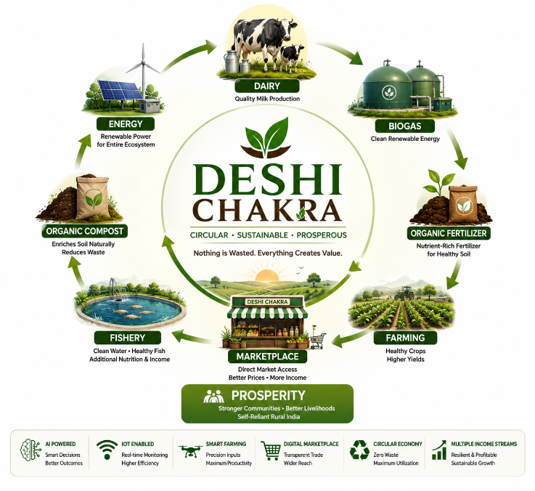

Explore the Deshi Chakra Ecosystem
Walk Through India's First AI-Powered Self-Sustaining Rural Ecosystem
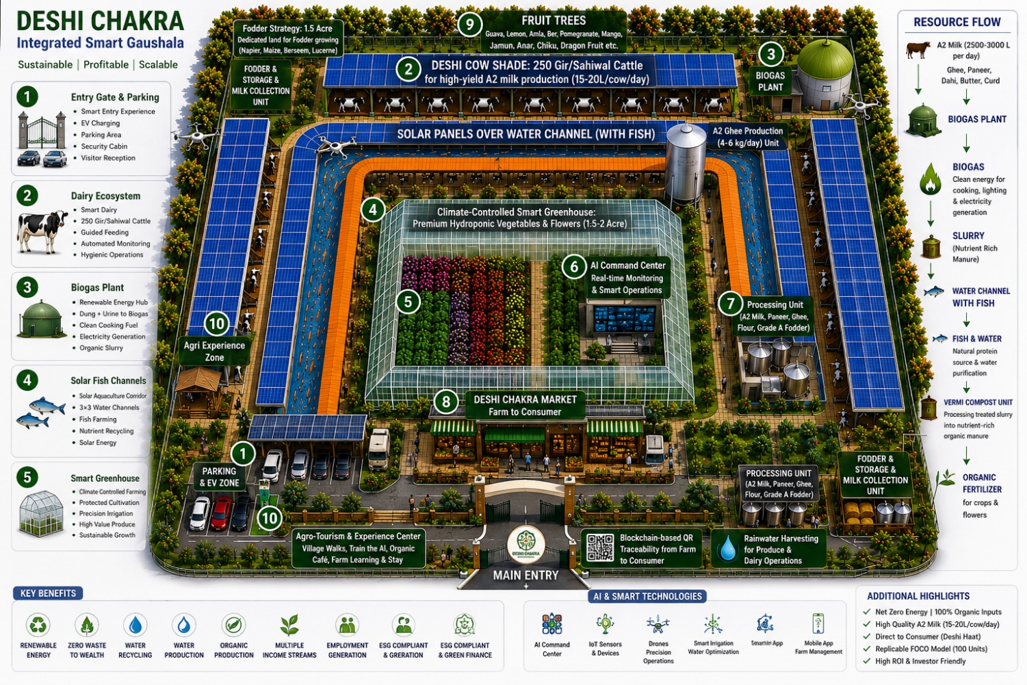
Multiple Revenue Streams. One Integrated Ecosystem.
Subheading
Diversified income sources designed for sustainable profitability and long-term resilience.
Visual Layout (8 Cards)
🐄 Dairy Ecosystem
- A2 Milk Production
- Livestock Management
- Daily Cash Flow

🧀 Value Added Products
- Paneer
- Ghee
- Curd
- Processed Dairy Products

🐟 Fisheries
- Solar Water Channels
- Integrated Aquaculture
- Additional Revenue Source

🌱 Greenhouse Farming
- Protected Cultivation
- Premium Produce
- Year-Round Production

🍎 Orchard Belt
- Fruit Trees
- Natural Green Barrier
- Seasonal Income

♻ Organic Fertilizer
- Slurry Processing
- Vermicompost
- Organic Inputs

🏪 Deshi Chakra Market
- Farm to Consumer
- Retail Sales
- Better Price Realization

🌿 Agri Tourism & Learning
- Guided Visits
- Training Programs
- Rural Experience

Bottom Banner
One Ecosystem. Multiple Income Streams.

IMPACT & TECHNOLOGY
Section Heading
Technology with Purpose. Impact with Scale.
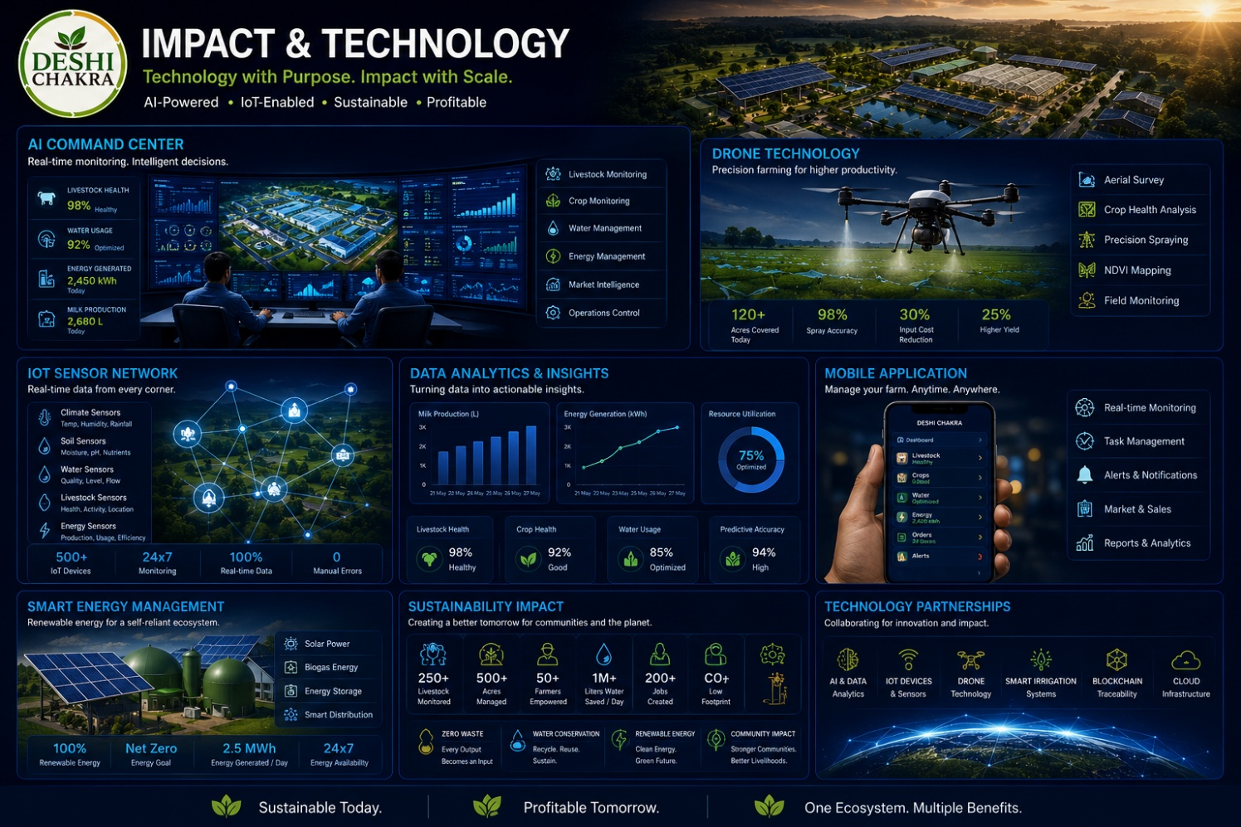

Left Side – Technology Layer
🤖 AI Command Center
Real-time monitoring and analytics.

📡 IoT Sensors
Water, climate and livestock intelligence.

🚁 Precision Agriculture
Drone-assisted spraying and monitoring.

📱 Mobile Applications
Farm operations and digital commerce.

📈 Predictive Insights
Early disease detection and productivity optimization.

⚡ Smart Energy Management
Solar and biogas-based operations.

Right Side – Impact Metrics
👨‍🌾 Farmers Empowered
Supporting producers and rural entrepreneurs.

👷 Employment Generation
Creating sustainable livelihoods.

♻ Zero Waste Operations
Every output becomes an input.

💧 Water Conservation
Recycling and efficient utilization.

🌍 Low Carbon Footprint
Renewable energy and sustainable practices.

🇮🇳 Nation Building
Strengthening villages and local economies.

Highlight Banner
Sustainable Today. Profitable Tomorrow.

INVESTMENT OPPORTUNITY :
Section Heading
Investing in the Future of Rural India
A scalable, technology-enabled, circular economy model.
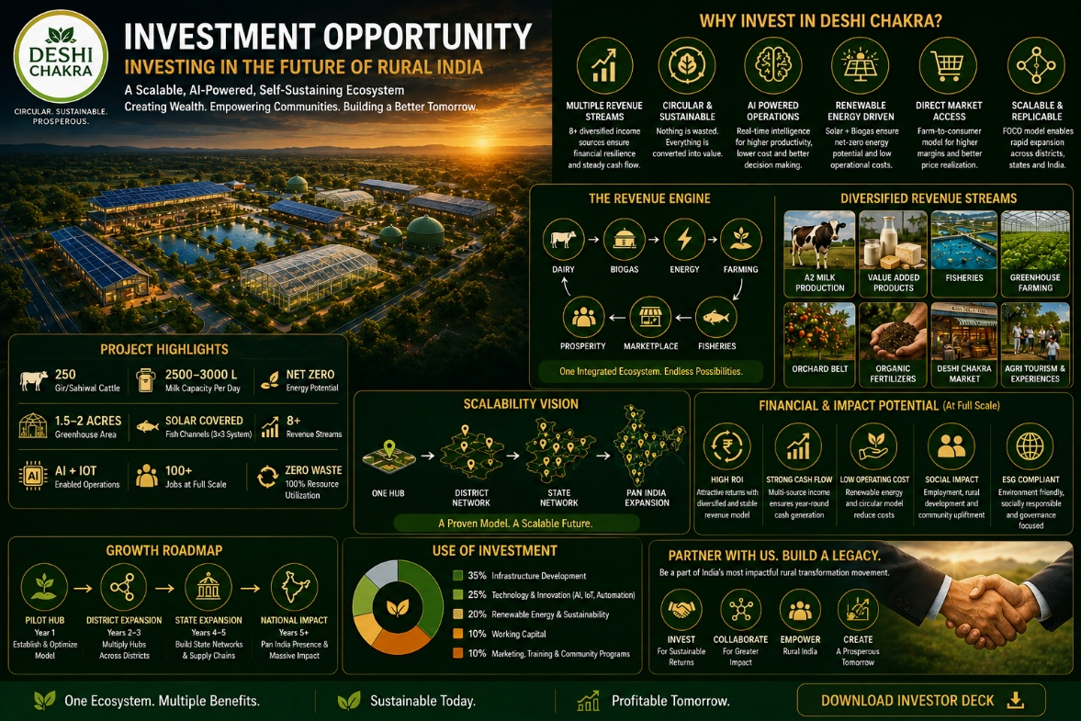

Why Deshi Chakra?
✔ Diversified Revenue Streams
Multiple independent income sources.

✔ Resource Optimization
Nothing is wasted. Everything creates value.

✔ AI Powered Operations
Technology-enabled efficiency.

✔ Renewable Energy Driven
Reduced operating costs.

✔ Direct Market Access
Higher margins and better price realization.

✔ Replicable Model
Designed for expansion across India.

Scalability Vision
One Hub
↓
District Network
↓
State Network
↓
Pan-India Expansion

Investment Highlights
Parameter | Highlights
Model | Integrated Circular Economy
Revenue Sources | 8+
Energy | Net Zero Potential
Technology | AI + IoT Enabled
Market Access | Direct-to-Consumer
Expansion | FOCO Replicable Model
Impact | Employment + Sustainability
Call to Action
Join Us in Building Prosperous Rural Ecosystems
Partner • Invest • Collaborate
[ Download Investor Deck ]

Other Related Texts that can be used :
Deshi Chakra is a self-sustaining, AI-enabled, zero-waste agri-industrial ecosystem integrating dairy farming, biogas generation, organic farming, floriculture, aquaculture, fertigation, organic fertilizer production, renewable energy, smart farm management, and direct-to-consumer market linkage.
The project is designed on a circular economy model where every output becomes an input for another component, ensuring:

- Zero waste generation
- Multiple revenue streams
- Reduced operational cost
- Sustainable resource utilization
- ESG-compliant operations
- Long-term profitability and scalability

India’s agriculture sector is rapidly shifting toward sustainable, integrated, and value-added farming systems. Conventional farming faces multiple challenges:

- Rising fertilizer costs
- Increasing energy expenses
- Water scarcity
- Dairy profitability instability
- Low farm gate realization
- Waste management issues
- Climate change impact

Deshi Chakra addresses these issues through:

- Integrated dairy and agriculture
- Renewable energy generation
- Circular nutrient economy
- Organic and premium product
- Smart agriculture technologies
- Direct farmer-to-consumer supply
The project aligns with:

- National Dairy Development objectives
- Organic farming promotion
- ESG and green finance goals
- Circular economy models
- Sustainable Development Goals (SDGs)
- Rural employment generation
- Carbon footprint reduction


Meet Our Founder

Sudheesh Nandan Singh
Founder & Visionary, Deshi Chakra

Engineer. Industrialist. Author. Nation Builder.

With more than three decades of experience across engineering, infrastructure, manufacturing, and entrepreneurship, Sudheesh Nandan Singh has dedicated his life to creating systems that generate long-term value for society.

From building successful engineering and steel enterprises to representing industrial interests in Bihar, his journey has been defined by discipline, innovation, and purposeful leadership.

Inspired by India's rural strength and entrepreneurial spirit, he founded Deshi Chakra with a mission to connect farmers, artisans, dairy producers, fisheries, and local businesses through a unified ecosystem that creates sustainable growth and market access.

His vision is to empower grassroots communities, promote self-reliance, and build a stronger economic future rooted in Indian values.

Founder’s Vision

"The future of India lies in strengthening its villages, empowering its producers, and creating opportunities that allow local communities to thrive. Deshi Chakra is a step towards that vision."

— Sudheesh Nandan Singh

Founder's Vision
"The future of India lies in strengthening its villages, empowering its producers, and creating opportunities that allow local communities to thrive. Deshi Chakra is a step towards that vision."
— Sudheesh Nandan Singh
Founder & Visionary

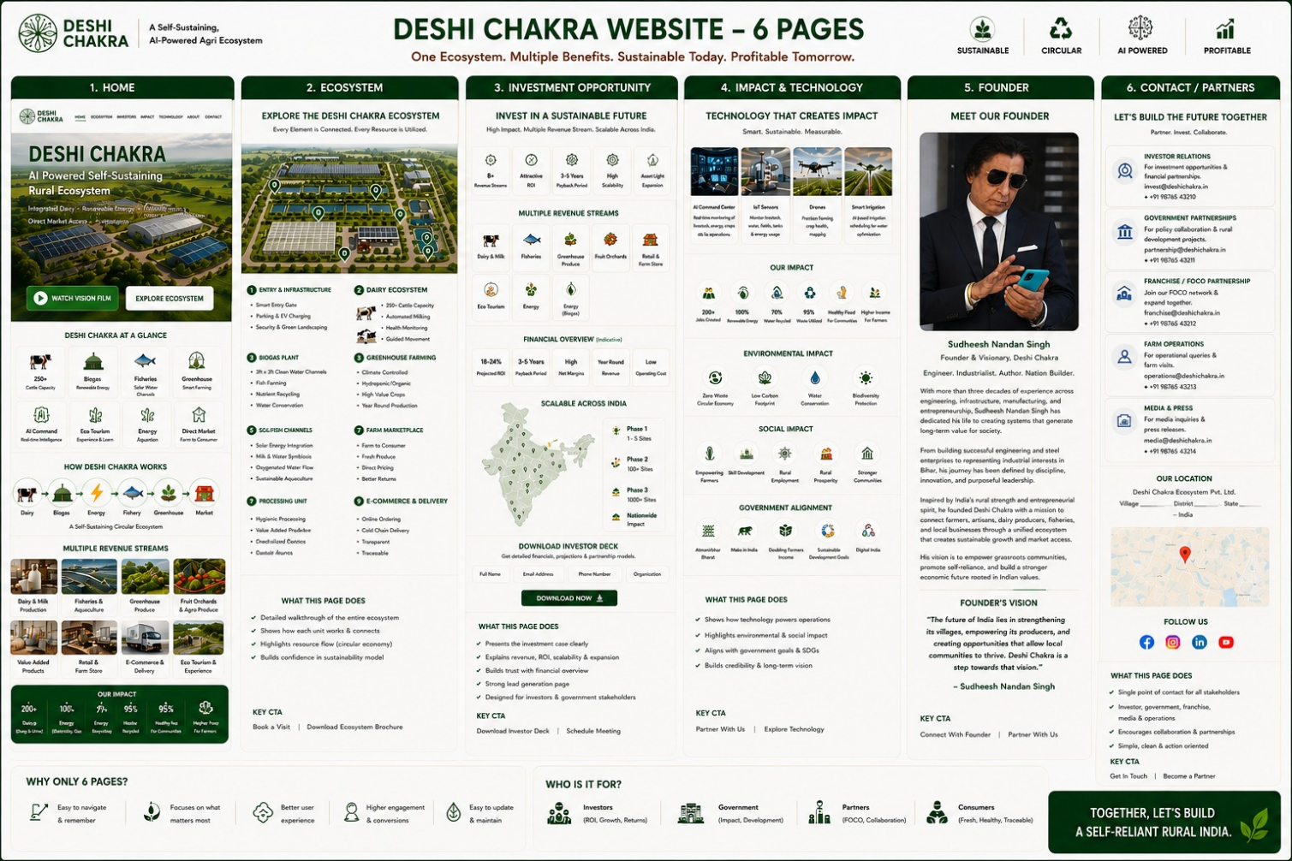
Structure Page

